Raspberry Pi App Engine

Complete Diagram paper

Version 1

Dylan Westra

11-07-2019

**Index**

General Overview 1

Server 2

Class diagram 2

Server events 3

Server Library’s 4

Apps 5

MediaPlayer 5

Server 5

Webclient 5

RpaeAudio 5

Server 5

Webclient 5

# General Overview

# Server

## Class diagram

The server is written in C++ with the Qt framework. Because Qt supports signals and slots I decided to also add the signals and slots in this diagram. There wasn’t much information in how to implement this into class diagrams. Thus the result is below.

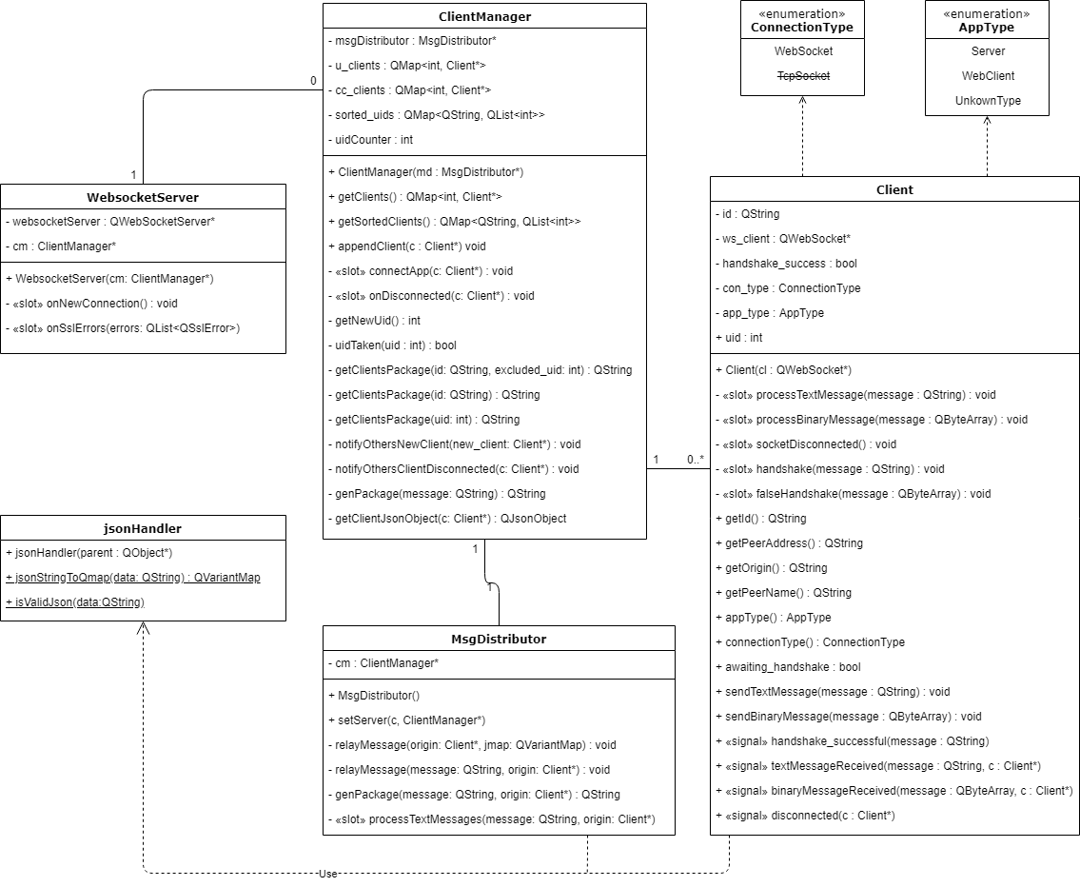

## Server events

This paragraph describes the events taking place inside the server and how they are all connected.

In Qt there is a system with signals and slots. A signal is as it says, a signal which can be connected in Qt by connect() with a receiver called a slot. In the diagram below you’ll see where all signals end up.

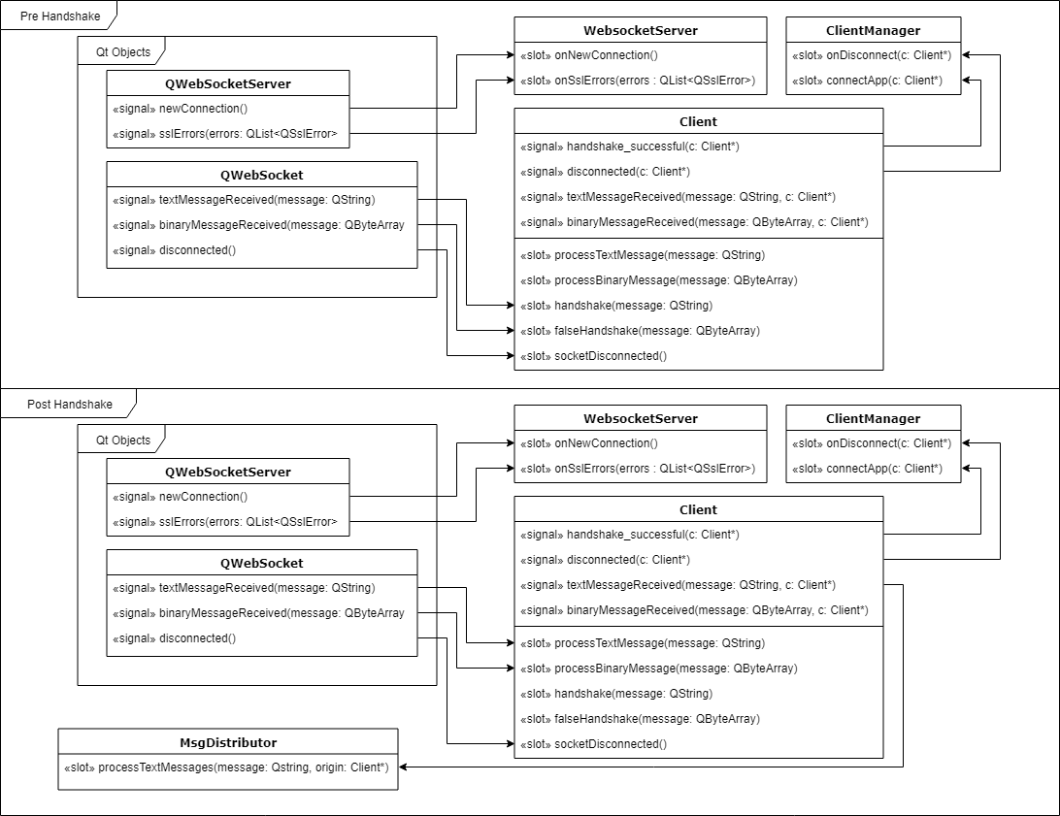

# Server Library

# Apps

## MediaPlayer

### Server

### Webclient

## RpaeAudio

### Server

### Webclient